Supplemental Table 1 – Candidate genes in QTL interval either: 1) expressed in floral and/or root tissues or 2) affecting flowering and/or root phenotypes
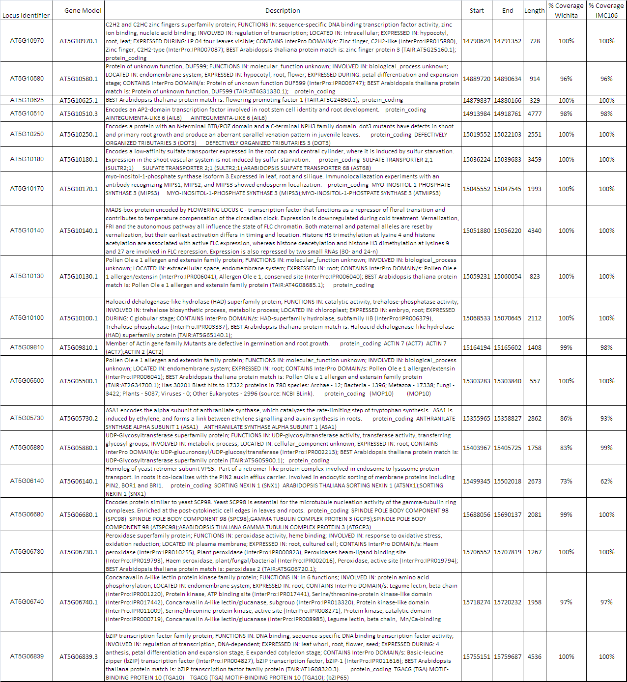

Supplemental Table 2- Summary of the SNPs (homozygous ) and InDels identified using SHORE consensus
Deletions | 471
Insertions | 491
InDels Total | 962
SNPs-Parent 1 | 2119
SNPs-Parent 2 | 1879
SNPs total | 3998

Supplemental Table 3- Summary of the SNPs (homozygous ) and InDels identified in candidate genes using SHORE consensus
Deletions- candidate genes | 11
Insertions- candidate genes | 11
InDels candidate genes- total | 22
SNPs candidate genes -Parent 1 | 88
SNPs candidate genes -Parent 2 | 49
SNPs candidate genes -Total | 137

Supplemental Table 4- Summary of the contig sequence size and number based on SUPERLOCAS analysis
Length | Parent1(before) | Parent1(after) | Parent2(before) | Parent2(after)
>=0 | 10278 | 10258 | 7079 | 7060
>=200 | 8037 | 8017 | 6016 | 5997
>=500 | 1611 | 1591 | 1737 | 1718
>=1000 | 353 | 356 | 366 | 373
>=5000 | 5 | 5 | 2 | 2
>=10000 | 1 | 1

Supplemental Figure 1 – Distribution of the estimated insert size plotted based on the results of SHORE correct4pe

Supplemental Figure 2- Analysis file output by SHORE consensus for Wichita parent line.

Supplemental Figure 3- Example analysis file output by SHORE consensus (copied from SHORE Manual (Ossowski et al., 2008)

Supplemental Figure 4- Alignment of cloned A10 FLC paralog from IMC106 and Wichita against the A. thaliana and B. rapa (Bra009055) FLC gene models.
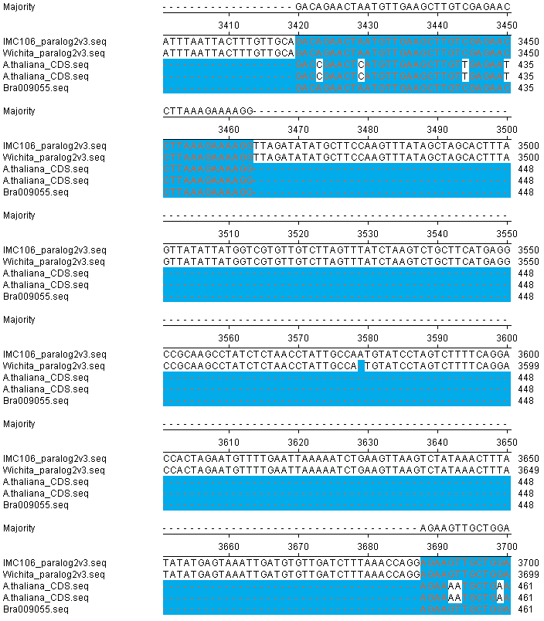
Exon 5
Exon 4
The deletion can be observed at position 3579

